“FCL e-book”: Table of Contents. V3.5
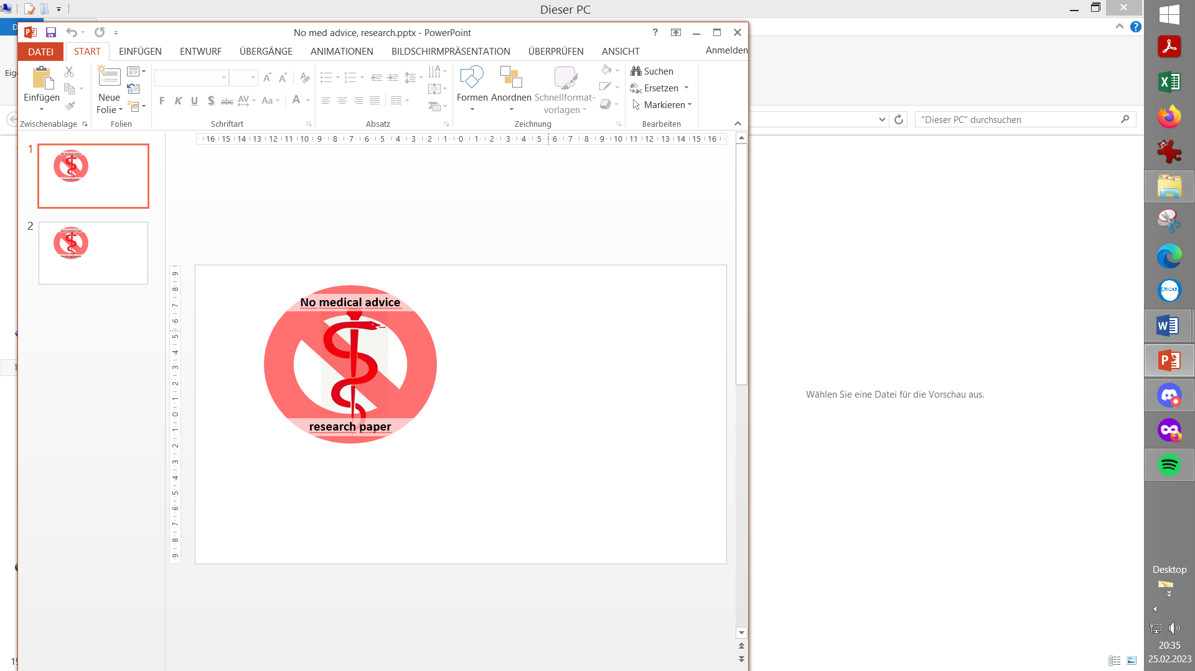

0. Introduction

1. Pre-requisites for Full Closed Loop
1.1 Well tuned hybrid closed loop
1.2 Fast insulin
1.3 Reliable insulin delivery from pump and cannula
1.4 Excellent CGM
1.5 Meal-related limitations?
1.6 Lifestyle-related limitations?
1.7 Time required for setting-up
Case study 1.1: Occlusion
Case study 1.2: Comparing insulins for FCL
Case study 1.3: Jumpy CGM
Case study 1.4: Lost pump connection
Case study 1.5: Permanent CGM values w/ 2x G6
Case study 1.6: When catastrophy strikes
Case study 1.7: MDI when the loop dies…
Case study 1.8: (placeholder for a Libre3 / 1.-minute case)…
…

2. General Settings for Full Closed Loop
2.1 SMB range extension
2.2 Max and min autoISF ratio
2.3 SMB delivery ratio
2.4 iobTH (iob_threshold_percent)
2.5 Eating Soon TT?
2.6 General settings in AAPS/Preferences

3. Description of autoISF / guidance by developers
3.1 Overview
3.2 ISF modulation flowcharts
3.3 Exercise mode and dynamic iobTH
3.4 Automation options with autoISF parameters
3.5 Activity monitor
3.6 Using one-minute CGM (Libre 3)
3.7 AutoISF parameters overview table
3.8 Emulator for logfile analysis and tuning
3.9 Links to related case studies/detailed doc.s

4. Meals: Setting ISF_weights in AAPS/Preferences
4.1 Getting started
4.2 bgAccel_ISF_weight
4.3 pp_ISF_weight
4.4 bgBrake_ISF_weight
4.5 dura_ISF and bg_ISF
4.6 Tuning your initial settings
4.7 Complex scenarios
4.8 Profile helper
Case study 4.1: Pizza
Case study 4.2: Low carb meals
Case study 4.3: Hands-off FCL around Christmas

5. Temp. modulation of autoISF aggressiveness
5.1 Automatic modulation of loop aggressiveness
5.1.1 autoISF off outside of meal windows
5.1.2 SMB off @ odd profile target
5.1.3 SMB off @ odd temp. target
5.1.4 Automatic diff. of FCL aggressiveness via Automations
5.1.5 Automatic diff. of FCL aggressiveness via Activity Monitor
5.1.6 Pro/con completely hands-off FCL
5.2 Manual modulation of FCL aggressiveness via DIY cockpit
5.2.1 Status recognition
5.2.2 Manual interventions from DIY cockpit
5.2.2.1 Temp. %profile or TT settings
5.2.2.2 Temp. settings in /preferences
5.2.2.3 Grey DIY cockpit buttons for pre-programmed FCL responses
5.2.2.4 Diff. of aggressiveness using “Automation State”
5.2.3 Temporary exit from FCL
5.3 Recognizing loop state from the AAPS home screen
5.3.1 Modulated loop aggressiveness (3 top buttons)
5.3.2 Color scheme of the top 3 buttons
5.3.3 Active Automations
5.3.4 FCL related indicator fields
5.3.5 Overall AAPS home screen
5.3.6 Extra graphs for autoISF
5.3.7 Info given every 5 minutes in the SMB tab
5.3.8 Info about last 15 autoISF decisions
5.3.9. SMB tab info when operating 1-minute Libre (needs work)
Summary: Your personal FCL cockpit
Case study 5.2: Sweet snacks / Glühwein w/ DIY cockpit
Case study 5.3: Compression low

6. Temp. modulation for exercise and light (In-)activity
6.1 Dynamic iobTH and sensitivity ratio
6.1.1 Manual (direct) iobTH modulation
6.1.2 Automations for iobTH modulation
6.1.3 Dynamic iobTH
6.2 Temp. % profile switch
6.3 DIY cockpit based on User action Automations
6.4 Mastering the exercise after meal challenge
6.4.1 Manual mode
6.4.2 DIY cockpit button for User action Automation
6.5 Activity monitor based on step-counter
Case study 6.2 Biking day with hi carb lunch; DIY cockpit

7. Advanced HCL (meal announcement via pre-bolus)
7.1 Hurdles for FCL
7.2 Getting ready to advance from HCL
7.3 Reduced pre-bolus
7.4 Tuning autoISF in HCL
7.5 Dealing with disturbances/ins. sens/resistance
7.6 Exercise management
7.7 Remote control (small children) (fragment, to be completed)
7.8 Other methods w/ meal announcement (MA)
Case study 7.1: Meal Announcement (5y old)

8. Performance monitoring and tuning
Case study 8.2: Futility of tuning based on 1 extreme meal

9. Trouble shooting
Case study 9.1: Un-intended loss of loop aggressiveness

10. Emulator on PC to determine settings
10.1 Installing the Emulator on your PC
10.2 Analyzing loop decisions in logfiles
10.3 What-if analysis

11. Emulator on the smartphone
11.1 Installing the emulator on your smartphone
11.2 Checking loop decisions on the smartphone
11.3 Options available on i-Phone (for Trio or iAPS, placeholder)
11.4 Real-time checking a „what-if“ question using speech synthesis

12. Remarks for users of previous autoISF version

13. Other avenues to Full Closed Loop
13.1 FCL using AAPS Master and Automations
Case study 13.1: Comparison: 1 month FCL, using Automation vs autoISF
13.2 dynamicISF used for Full Closed Loop
Case study 13.2: Using dynISF for FCL (sorry, nobody provided interpretable data yet)
13.3 Methods involving simple meal announcement that might be stretched into a FCL
13.3.1 Boost
Case study 13.3: Boost-based FCL for a child
13.3.2 AIMI,
13.3.3 EatingNow
13.3.4 Tsunami
13.4 No-bolus looping with precise carb inputs
13.5 Machine Learning (AI)
13.6 Dual hormone systems
13.7 Co-Medications that might facilitate FCL
Final Remark

